Date:13/03 Fecha de Entrega :17/04 Enviar: czanotti@institutonsvallecba.edu.ar
Libro: The Big Picture B1 Pre-Intermediate student´s book
Ed: Richmond
Diccionario : puede utilizar cualquiera.
IMPORTANT: READ YOU MUST WRITE YOUR NAME, SURMANE AND COURSE
AND SEND IN M.WORD. ANSWERS Vocabulary 1,2,3,5/Adj and prepositions 6 y 8a , 9, Must and don´t have to … 3y 4. Listening ANSWERS 1,2,3 y 4 PROLIJO
- Read and complete in your foulder.
Complete in your folder
Vocabulary Unit 5
Page 28. 1 Crossword
Across 4., 5,7.8.9
Down 1,2,3,5,6
2 Complete the words
1,
2,
3,
4,
5,
6,
7,
3-Complete the sentences
1
2 etc una palabra en cada renglón
4- NO HACER
5 ED/ ing Adjectives si hacer

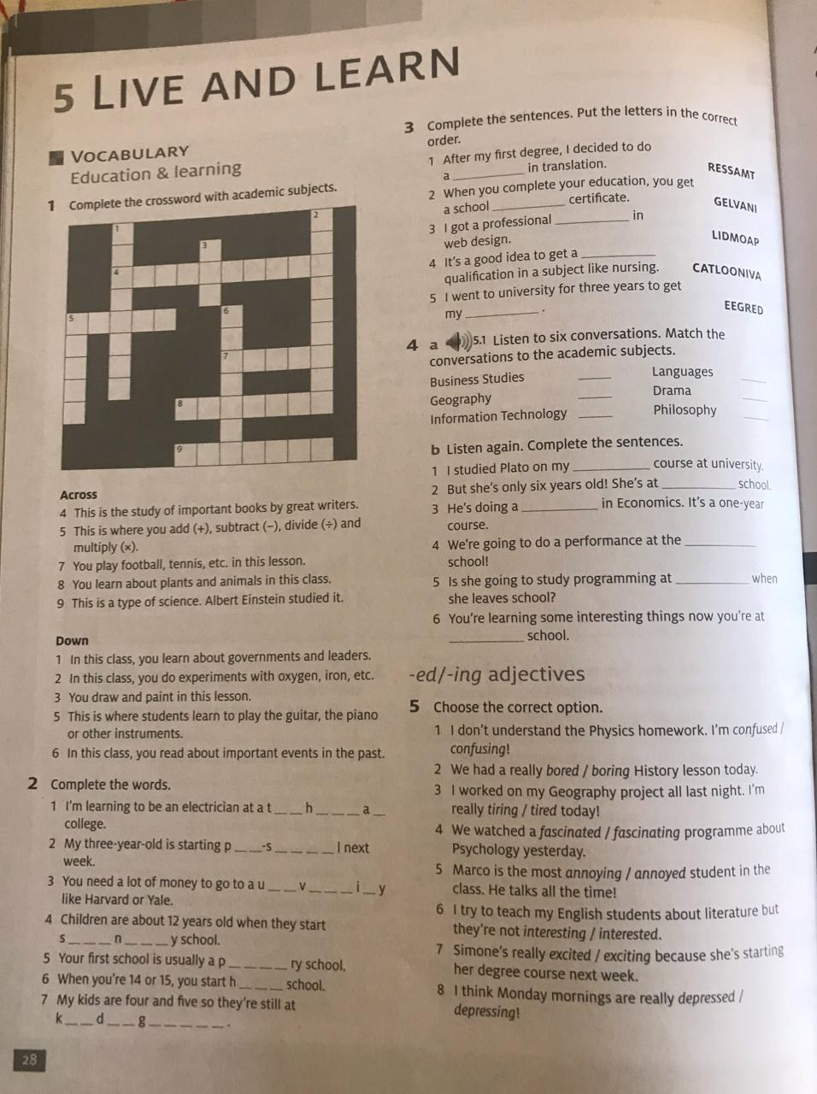

Prepositions
You can use ing form after an Adjective and preposition example: I´m good at swimmning.
I´m interesting in learning languages.
Adjetives | Prepositions
Good | at
Bad
Bored | with
Interested | in
Enjoy | something
like
love
Exiced | about
Different | From or to
Adj + prepositions
6 Choose the correct option
Escribir toda la oración en la carpeta.
7 . Read and Complete act 8a , 8 b is in the book at the end.
Act 9 Complete
1
2
3 etc

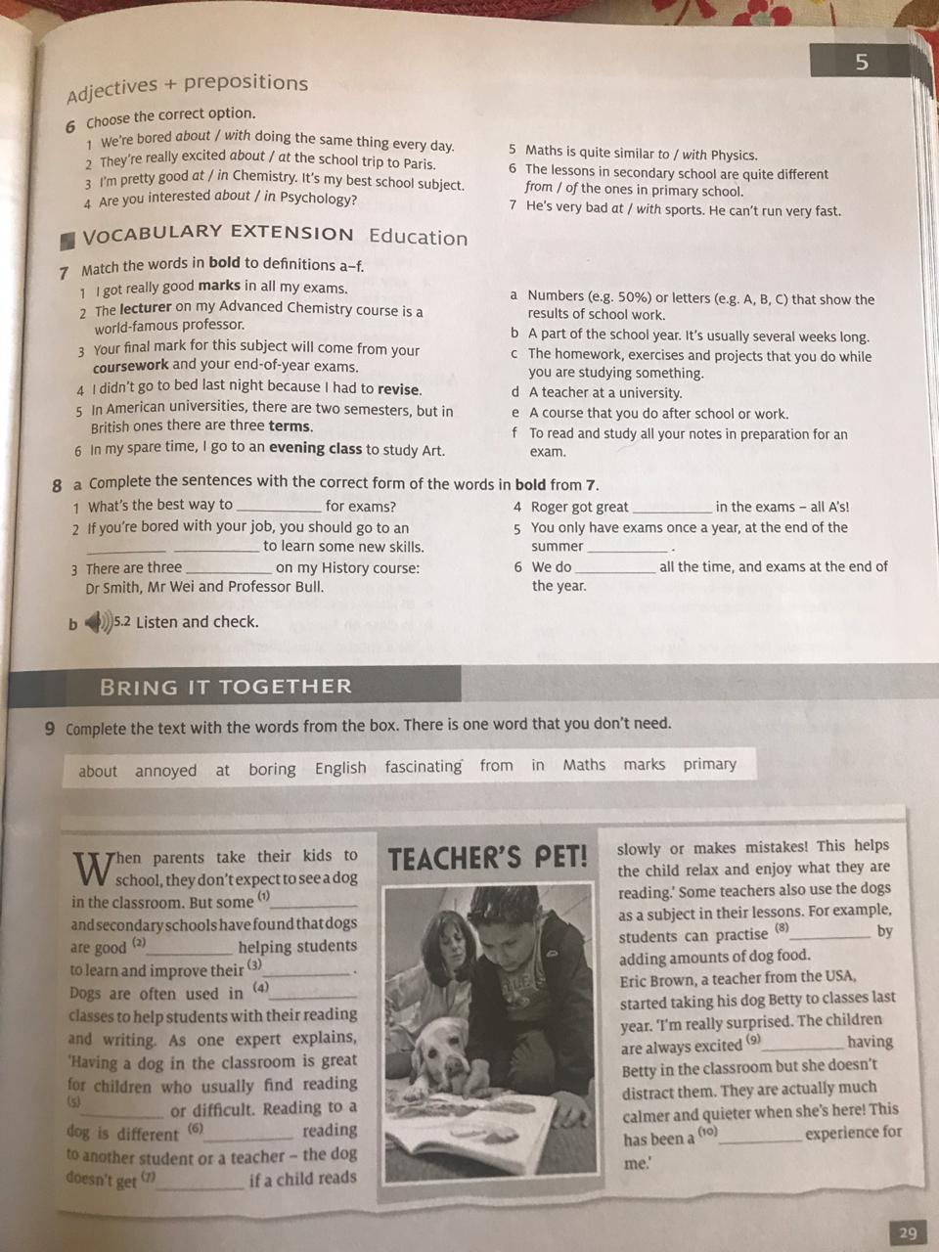

Complete in the folder
- ( con la letra que le corresponde)
2
3
4
5
6
7
4. Choose the correct option
1,
2 etc

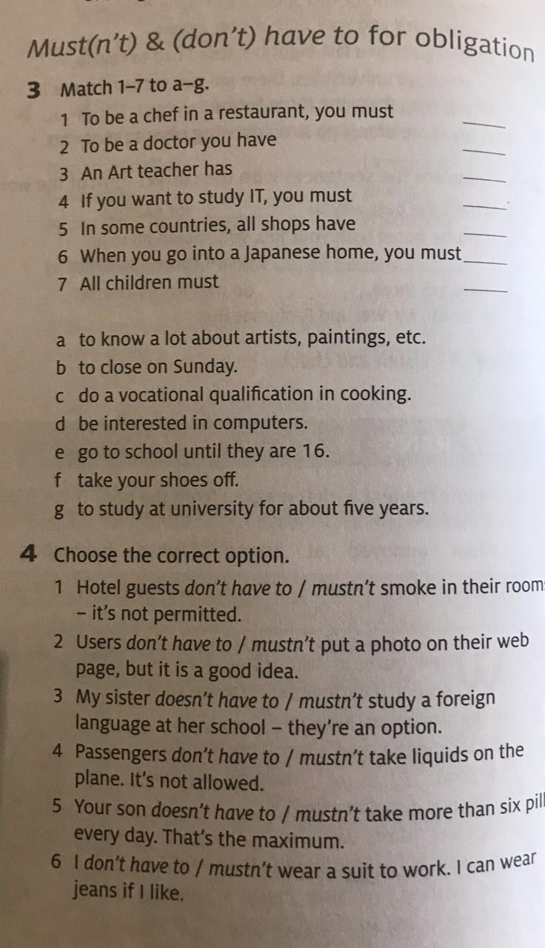

Listening: Queen´s message from the BBC
https://www.bbc.com/news/entertainment-arts-52183327?intlink_from_url=https://www.bbc.com/news/topics/cq23pdgvr7rt/queen-elizabeth-ii&link_location=live-reporting-story
Listen and answer the questions
1 Who ´s she?
2 Where´s she from?
3 What´s the main idea?
4 Did you understand?

