ESCUELA NUESTRA SEÑORA DEL VALLE
Queridos chicos y estimados padres:
Comenzamos otra semana con nuevos desafíos!
¡Gracias por el acompañamiento! Un afectuoso saludo Miss Marian

June 8th, 9th and 10th 5th grade
- Routine: Play ! 1-https://agendaweb.org/exercises/vocabulary/daily-routines/routines
2-https://www.montsemorales.com/vocabulario/routines2b-spot.htm

- Watch the presentation https://www.loom.com/share/2a4d4d2eb4f54aada15d7c070937e3f5

- Personal Pronouns: Revision
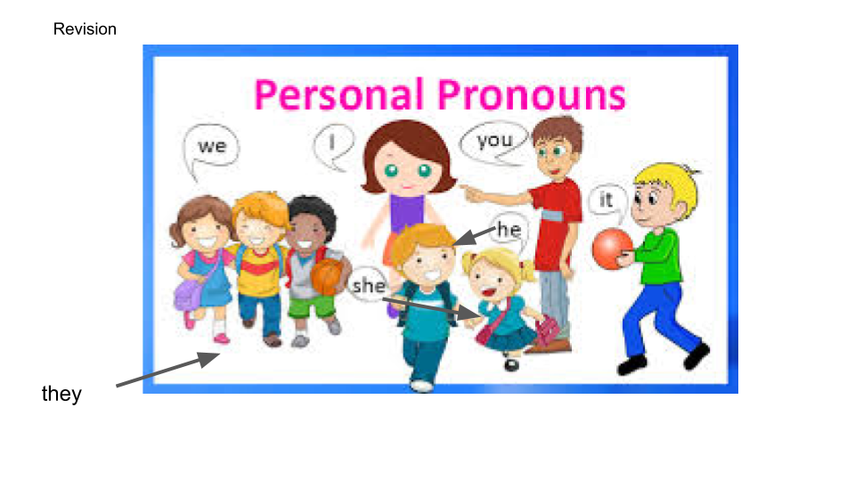

- Routine

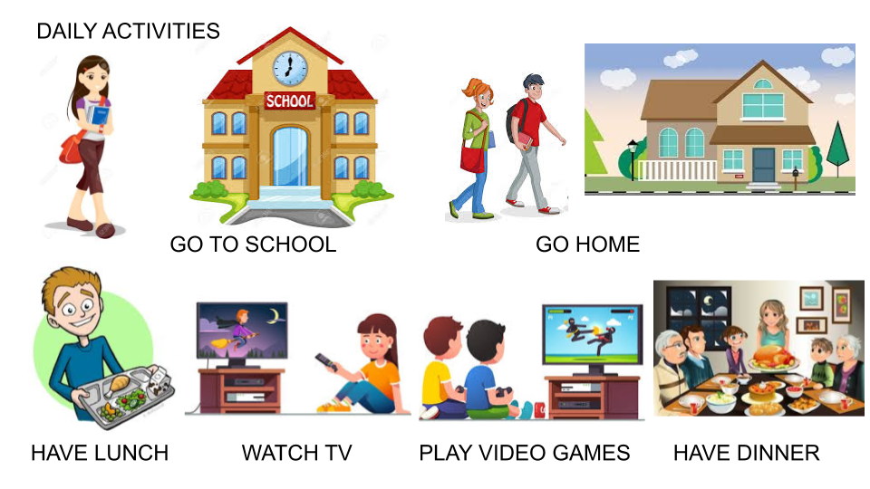

- Talking about routine ...
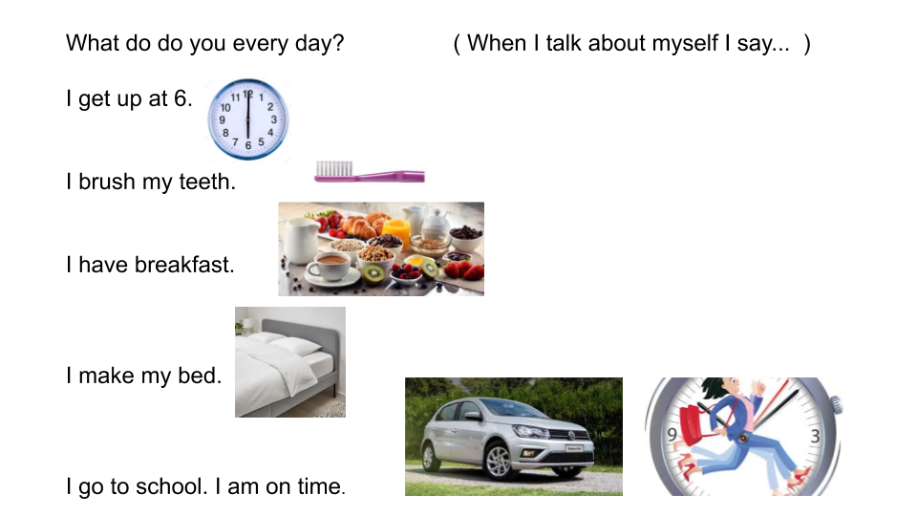

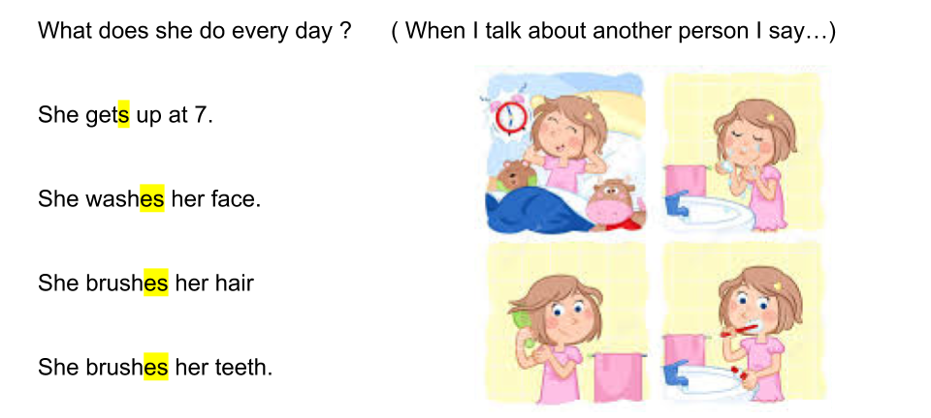
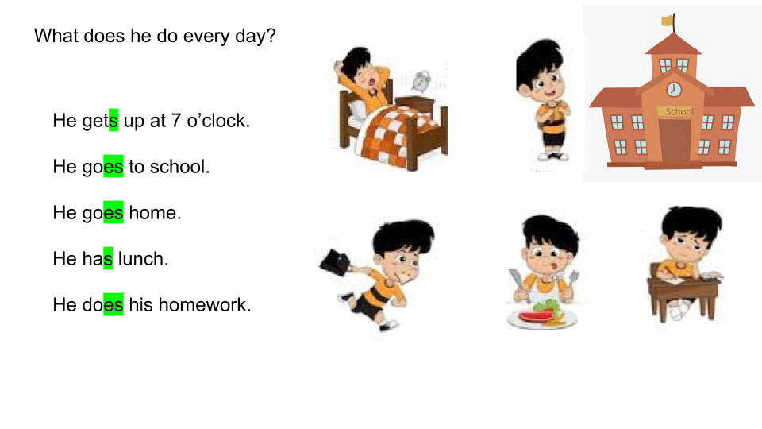
- Look !
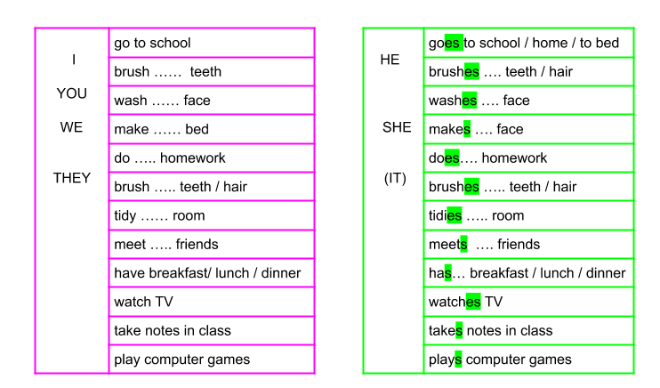

- Possessive Adjectives: Watch https://youtu.be/Q67V1ZbQQQM

- Look !

PERSONAL PRONOUNS | POSSESSIVE ADJECTIVES | EXAMPLES
I | MY | I brush my teeth
YOU | YOUR | You do your homework
HE | HIS | He makes his bed
SHE | HER | She tidies her room
IT | ITS | It washes its face
WE | OUR | We tidy our house
THEY | THEIR | They meet their friends

- The time
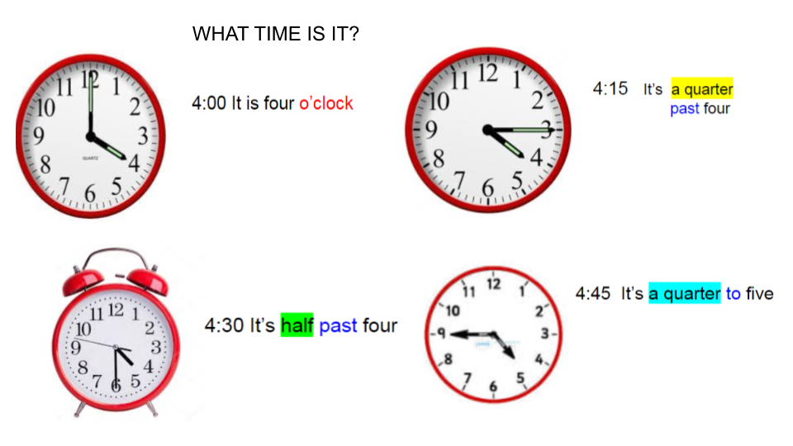
- The time: Let´s Play! https://agendaweb.org/exercises/vocabulary/time/time-1

- Watch the presentation https://docs.google.com/presentation/d/1PqWhD7BDkm9uy3acrLRXZPMR1vJrldWRgqZoeohSujM/edit?usp=sharing
Pupil’s book page 15 / Activity book page 13

- Now check your answers https://docs.google.com/presentation/d/11rF40yWrgUMQu9uSKPpZiKkRCIWSy1VEvMyj9Bfk5es/edit?usp=sharing

- Look and write the letter

- It’s seven o'clock ______ a- 8:00
- It’s a quarter past seven _____ b- 7:30
- It’s half past seven _____ c- 7:15
- It’s a quarter to eight _____ d- 7:00
- It’s eight o´clock ______ e- 7:45

