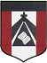
ESCUELA NUESTRA SEÑORA DEL VALLE
Estimadas familias y queridos chicos: ¡Buena semana! ¡Seguimos trabajando !
Link diccionario: https://www.wordreference.com/es/translation.asp?tranword=a

¡Saludos ! Miss Marian mfrontera@institutonsvallecba.edu.ar

May 18th, 19th and 20th 5th grade
Hello dear children ! How are you today ? _________________________________
- Revision What do you look like ? https://youtu.be/qhWV4fzchq4
- Watch the presentation https://docs.google.com/presentation/d/1ByBORL37aG9UGFaZSj3LuAK43UnkWojXxsN9oxV5Z9o/edit?usp=sharing
Pupil's book pages 9 and 10 / Activity book pages 9 and 10
- Read
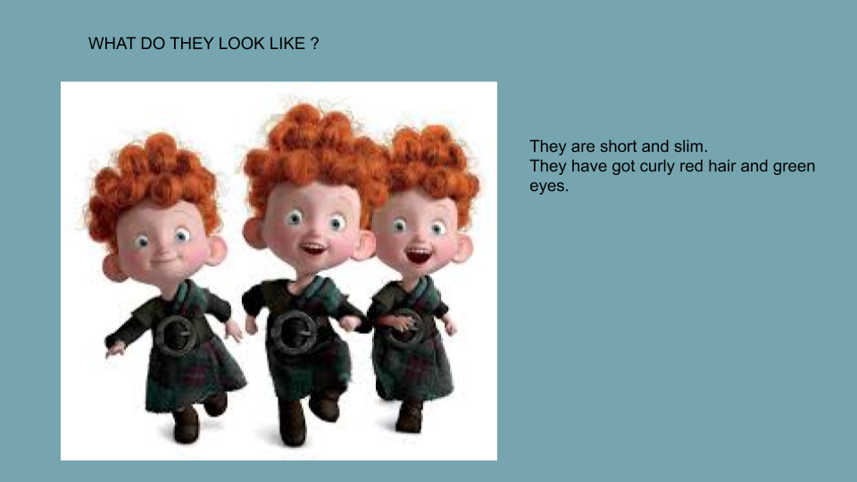

- Revision
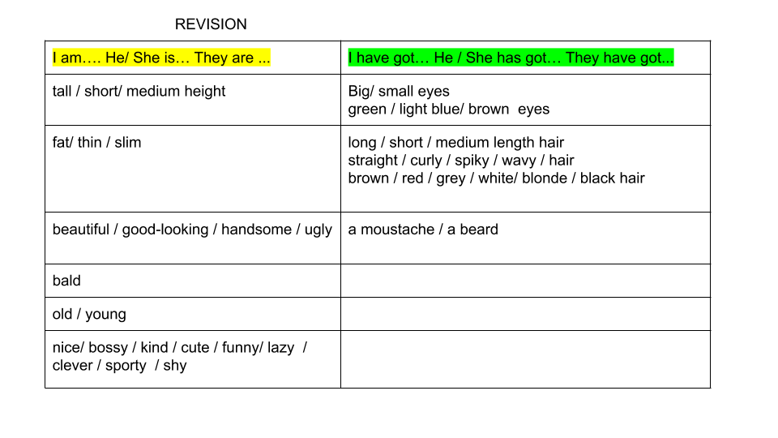

- Write “TRUE” OR “FALSE”
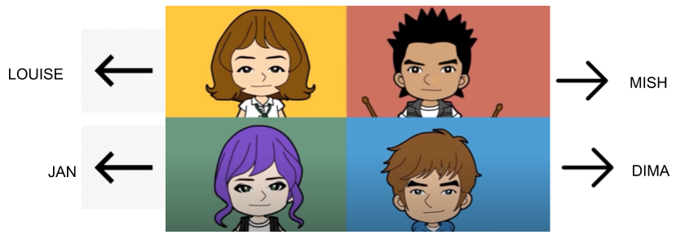
- Mish has got spiky hair. _________
- Dima is bald. ________
- Jan ´s got brown hair. ___________
- Louise has got wavy hair. _________
- Dima has got a beard and a moustache. __________
- Jan has got green eyes. _________
- Dima is young. __________
- Mish is very fat. ________

F. Read and draw

He is Mark.
He has got short spiky blonde hair and big blue eyes.
He's got a beard and a moustache.
He is handsome.
He is young.
He is tall and slim.
He is sporty.

.

She is Sarah.
She has got long straight brown hair and small blue eyes.
She is short and thin.
She is beautiful.
She is kind.

Bye, bye ! Miss Marian

