Date: 20/03 Fecha de Entrega : 24/04 NO ENVIARLO NUEVAMENTE. AUTOCORRECCIÓN
Enviar las respuestas Book page 54 a czanotti@institutonsvallecba.edu.ar
Libro: The Big Picture B1 Pre-Intermediate student´s book Ed: Richmond
Diccionario : puede utilizar cualquiera.
IMPORTANT: READ SELF CORRECTION These are the ANSWERS and the Listening please check and Listen to it again. Thank you. No enviarlas nuevamente/ Enviar actividades page 54
*Hello Students: HOW ARE YOU? I hope you are FINE
Keep on working like this, very good Job!! Luego a través de Google Clasroom les llegará la actividad. Tips para tener en cuenta:
- Repasar los temas dados, tanto vocabulario como gramática
- Responder en forma ordenada e individual.
- Leer y Completar Book Page 54 Culture and Tradition Activity 1. Do it individually, 2 a and b . Read the Blue box NOTICE and write activity 3 Work individually not in pairs.
(al último adjunté la hoja para aquel que el falte el material)
SELF CORRECTION . Please check in your foulder.
Vocabulary Unit 5
Page 28. 1 Crossword
Across 4 Literature., 5 Maths ,7 Sport .8 Biology .9 Physics
Down 1 Politics ,2 Chemistry ,3 Art ,5 Music ,6 History
2 Complete the words
1, Technical 2, pre-school
3,University 4 Secondary
5 primary 6 high 7,kindergarten
3-Complete the sentences
1 Master 2 Leaving 3 Diploma 4 Vocational 5 Degree
4- NO HACER
5 ED/ ing Adjectives si hacer
1 confused, 2 boring, 3 tired, 4 fascinating, 5 annoying 6 interested 7 excited 8 depressing
- Read and complete in your foulder.
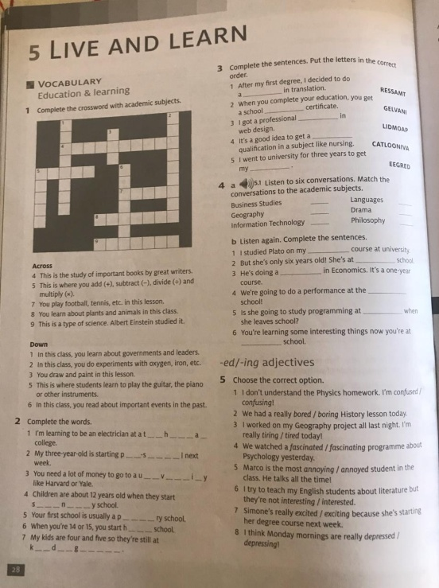

Prepositions
Adjetives | Prepositions  Adj + prepositions  6 Choose the correct option  Escribir toda la oración en la carpeta.  1 with, 2 about, 3 at, 4 in, 5 to, 6 from, 7 at  7- no había que realizar, Answers 1 a, 2d,3c, 4f,5b, 6e  7 . Read and Complete act 8a , 8 b is in the book at the end.  8.a 1) revise 2) Evening class, 3 lecturers 4) marks, 5) term 6) Coursework  Act 9 Complete  1Primary 2 at 3 marks  4 English 5 Boring 6 from  7 annoyed 8 Maths, 9 About 20 fascinating

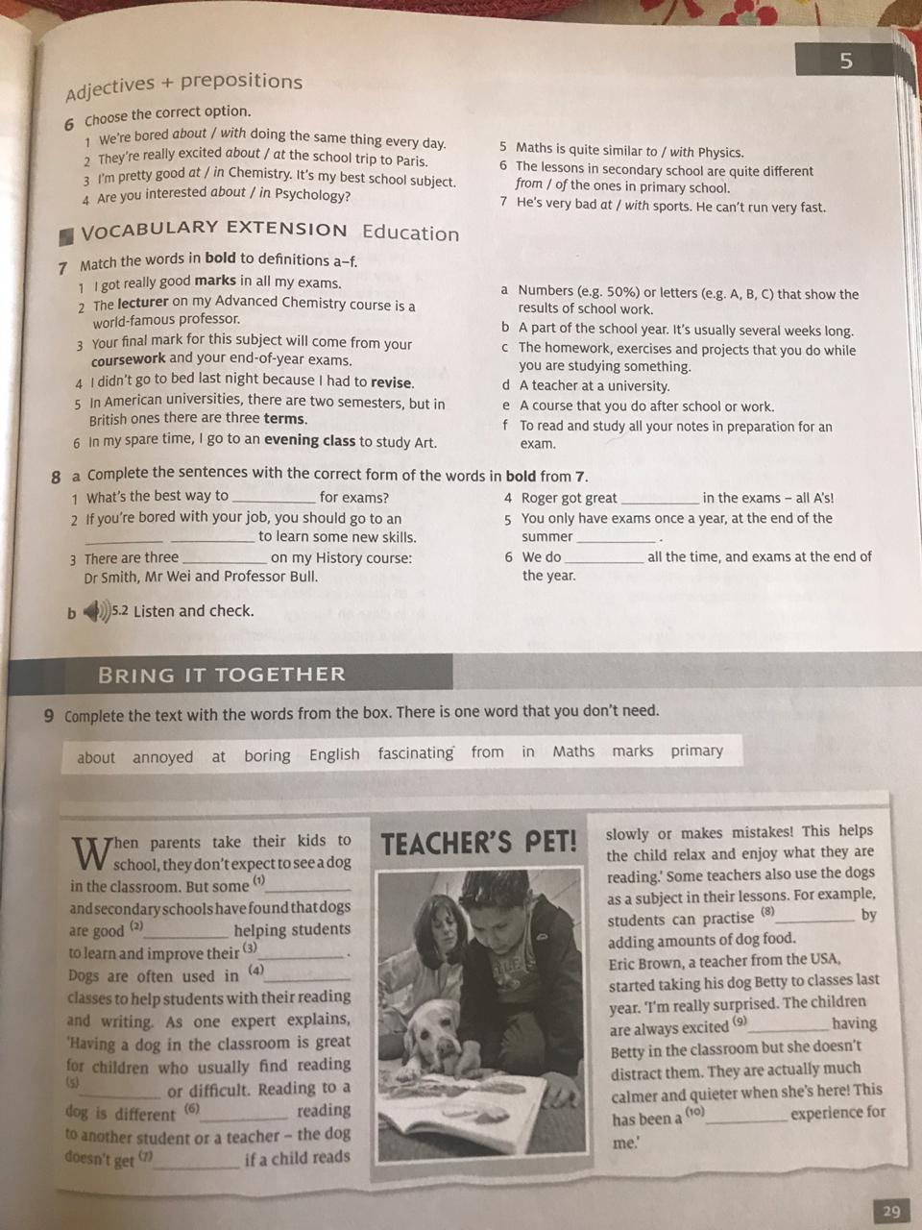

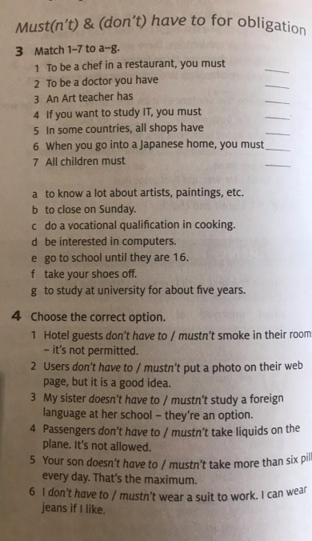
Complete in the folder
( con la letra que le corresponde)
1c
2 g 3 a 4d 5b 6f 7e
4. Choose the correct option
1, Mustn´t 2 don´t have to 3 doesn´t have to, 4 mustn´t 5 mustn´t 6 don´t have to

Listening: Queen´s message from the BBC
https://www.bbc.com/news/entertainment-arts-52183327?intlink_from_url=https://www.bbc.com/news/topics/cq23pdgvr7rt/queen-elizabeth-ii&link_location=live-reporting-story
Listen and answer the questions
1 Who ´s She? 1). She is the Queen of the United Kingdom of Great Britain and Northern Ireland and of her other realms and territories Queen. Her full name is Elizabeth Alexandra Mary Winsor. Officially Elizabeth II, by the Grace of God
*Other Realms and Territories Queen.
2 Where´s she from? 2) She is from the United Kingdom, London
3 What´s the main idea? The challenge ! Please listen to it again.
4 Did you understand? The question is in Simple Past, the answer is with the Simple Past
Yes, I did, /No, I didn´t. OR Yes, I understood. It´s ok if you wrote, I didn´t undestand. You need to practice listening. That´s why I invite you to listen to the message again. The message starts with a big thank you to all those who work in the first line, but There is a Challenge…. What is it?
ACTIVIDAD NUEVA. READ
*Leer y Completar Book Page 54 Culture and Tradition Activity 1. Do it individually (Escribir cada respuesta), 2 a and b . Read the Blue box NOTICE and write activity 3 ( un párrafo que reúna todas esas preguntas ( 6 renglones como máximo) Work individually, not in pairs.
(al último adjunté la hoja para aquel que le falte el material)

Objetivos: que el alumno:
-reconozca el vocabulario trabajado y las estructuras gramaticales.
-responda en forma ordenada e interprete la consigna.
-sea responsable de su trabajo individual y realice la actividad a tiempo.
BOOK, PAGE 54

