ESCUELA NUESTRA SEÑORA DEL VALLE

3rd grade
September 28th and 29th

Hello dear children ! _____________________
How are you today ? ____________________

- Parts of the house . Play ! https://agendaweb.org/exercises/vocabulary/house/rooms

- In / on / under Watch https://youtu.be/8F0NYBBKczM

- Parts of the house : Watch https://youtu.be/JlKANbZ7Vpg

- Watch https://www.loom.com/share/0043acc8d1824441a6c648a611cf5f5b

- In / on / under

- Where …?
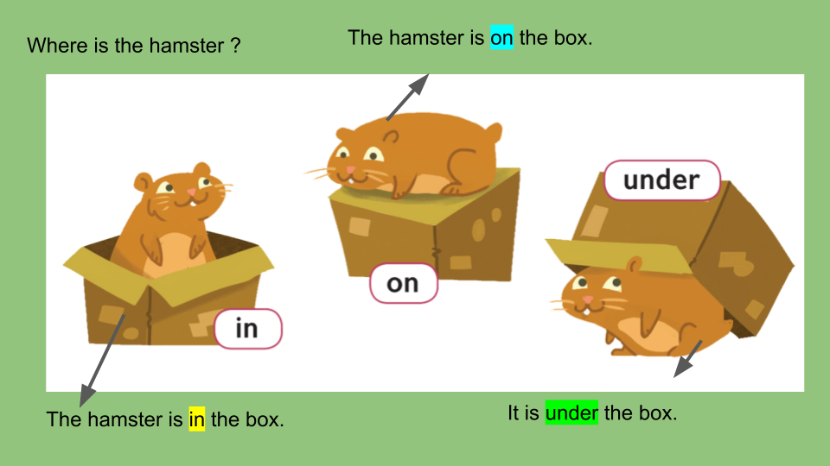

- Vocabulary

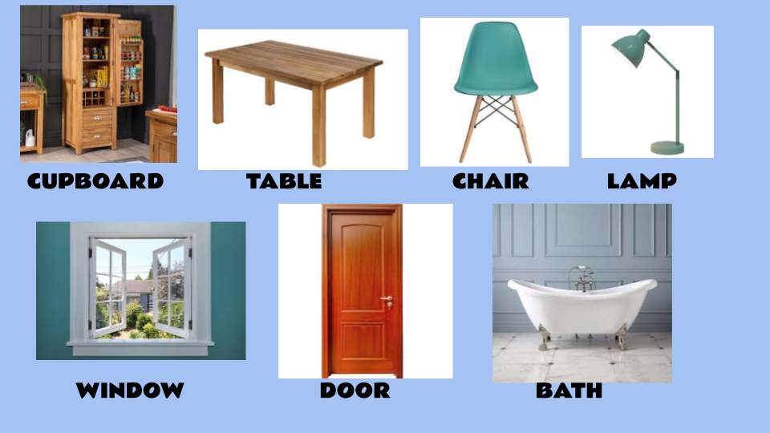

- Watch https://www.loom.com/share/493822768ea342cc93ba864e4b309691

- Watch https://docs.google.com/presentation/d/11t_vgDTiVvQ_yd8HU6VL4aN7mdzafrgZEQMj2ymB9ek/edit?usp=sharing
Pupil’s book pages 36 and 37 / Activity book pages 30 and 31

- Check your answers https://docs.google.com/presentation/d/1-0OAH-eBI7kHY7hrSKeEPT7pVYzoznaU_BJpQOI20zo/edit?usp=sharing

- Look and answer
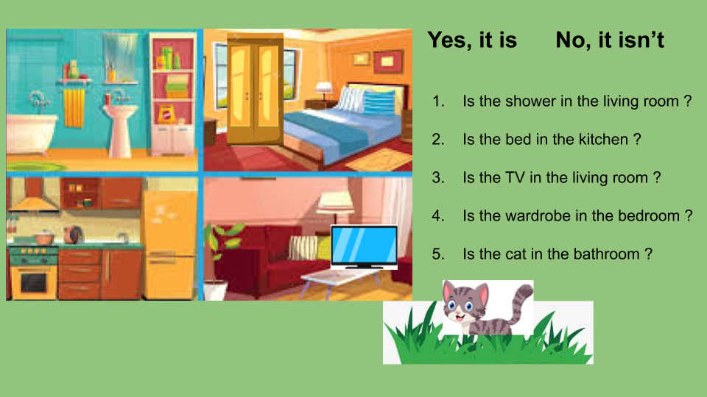

- _________________________
- _________________________
- _________________________
- _________________________
- _________________________

L. True or False : In my house …
- The TV is in the bathroom __________.
- The bed is in the garden. ___________.
- The cooker is in the kitchen __________.
- The shower is in the living room. _________
- The sofa is in the living room. ____________

Miss Marian

