ESCUELA NUESTRA SEÑORA DEL VALLE

ACTIVITIES JUNE 12TH TO 19TH 6TH GRADE Miss Liliana
Este “Family Tree” puede ayudarte a entender las relaciones familiares….
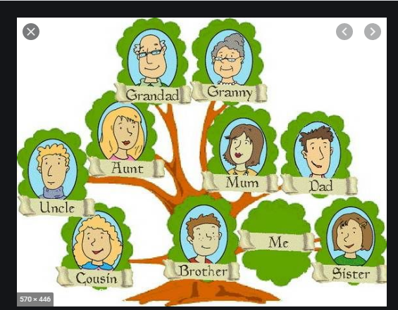

REVISION….revisamos lo hecho en la videoconferencia….
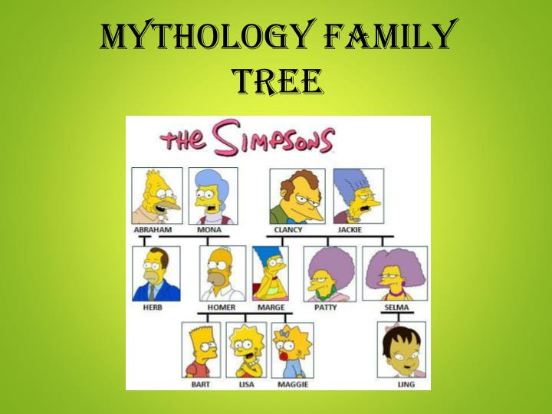
ANSWER ABOUT THIS FAMILY TREE (aquí aparece una palabra “who” que quiere decir “quien”)
Is Abraham Mona´s husband?
Who is Marge´s mother?
Is Maggie Mona´s granddaughter?
Is Homer Herb´s brother?
Is Bart Lisa´s brother?
Is Marge Homer´s wife?

Estas preguntas pueden ayudarte a hacer la descripción. Escribilo en un párrafo, acordate que los párrafos tienen MAYÚSCULA y punto y seguido.
DESCRIBE A FAMILY MEMBER (Describir un miembro de tu familia)

Who is he/she?
How old is he/she?
What does he/she do?
What does he/she like doing?

.............................................................................................................................................................................
.............................................................................................................................................................................
.............................................................................................................................................................................
.............................................................................................................................................................................
Te dejo un sitio para jugar…
http://www.english-time.eu/hry/family-tree.php?zpet=teacher

