ESCUELA NUESTRA SEÑORA DEL VALLE

Queridos chicos y estimadas familias:Quiero agradecerles los regalos, los mensajes y las muestras de cariño que me han hecho llegar.. Fue hermoso ver sus caritas en los videos y así sentirlos cerca pese a la distancia. Los llevo en mi corazón a cada uno de ustedes.
Les hago llegar mi abrazo virtual. ¡Muchas gracias !
Los saluda con mucho cariño Miss Marian

September 14th, 15th and 16th 5th grade

- Revision : Complete using :

dancing / hitting / drawing / singing / kicking / acting

- Messi is very good at _________________.
- Del Potro is very good at _______________.
- Adam Sandler is very good at ________________.
- Tini is very good at _____________ and _______________.
- Miss Sole is very good at ____________________.

- Revision: There is / are Watch https://youtu.be/ZjhOgnROluo

- Watch https://www.loom.com/share/37cc9ae21f0040bd9f2b3bddcb0292d0

- Watch https://www.loom.com/share/b3b7114aef584401bf260f3b95c3f3e2

- Watch https://docs.google.com/presentation/d/1lDWLrEyiGD9OmqrIQPfvSOaE7WxnFgEc_nlBasZzz5E/edit?usp=sharing
Pupil’s book pages 34 and 35 / Activity book pages 30 and 31

- Now check your answers https://docs.google.com/presentation/d/1Kf9o601njv7tSWMMAgdYAPz-Z2lEDetNjAwiye_Raoc/edit?usp=sharing

- Places of interests
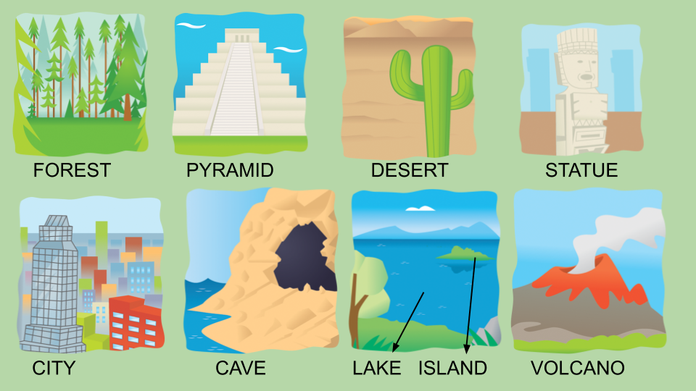

- Countries
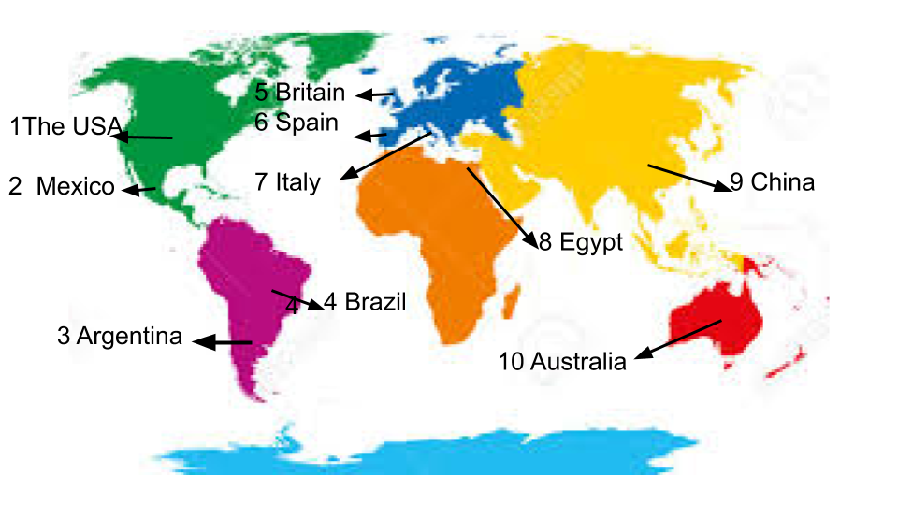

- Singular / Plural
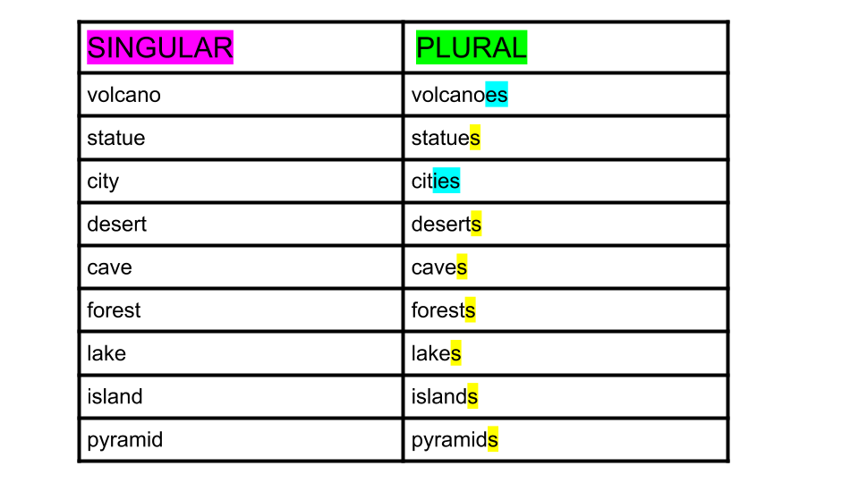

- There is a / There isn't a / There are some / There aren't any …

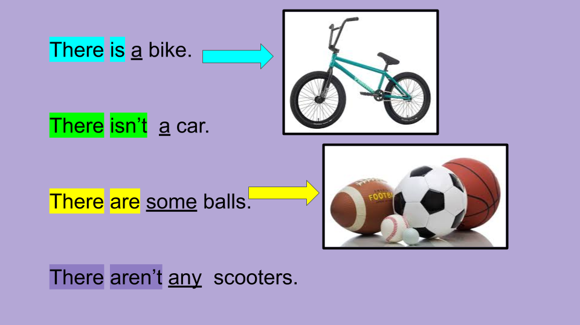

- True or false ?

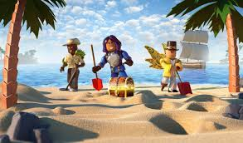

- There is a house. _____________
- There is a boat. ______________
- There are two trees. ______________
- There are some rocks. _____________
- There are some pyramids. ______________
- There are some clouds. ____________

- Complete using : There is / There isn’t / There are / There aren’t
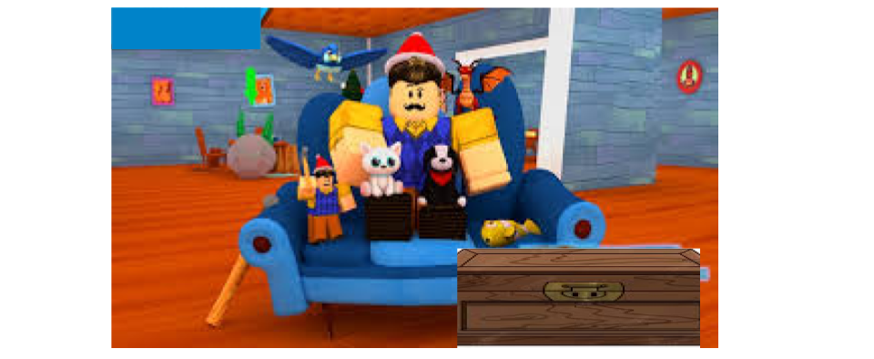
- _____________ ________ a computer.
- _____________ ________ a sofa.
- _____________ ________ some animals.
- _____________ ________ any books.
- _____________ ________ a TV.

Bye, bye !

