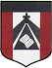
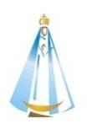
ESCUELA NUESTRA SEÑORA DEL VALLE

Queridos chicos y estimadas familias: ¡Continúan mis felicitaciones por los trabajos realizados! ¡Gracias ! ¡Seguimos trabajando ! Los saludo con cariño Miss Marian

June 22nd, 23rd and 24th 3rd grade

- We are in Winter !

- Watch Rock, paper, scissors https://youtu.be/awdJ0OGjqsc

- Play ! Rock, paper, scissors ( jugá con alguien de tu familia)
- The face Play ! https://agendaweb.org/exercises/vocabulary/body/body-face

- Watch https://www.loom.com/share/7a979241729646a6bbf289eb640b73cb

- Have you got… ?
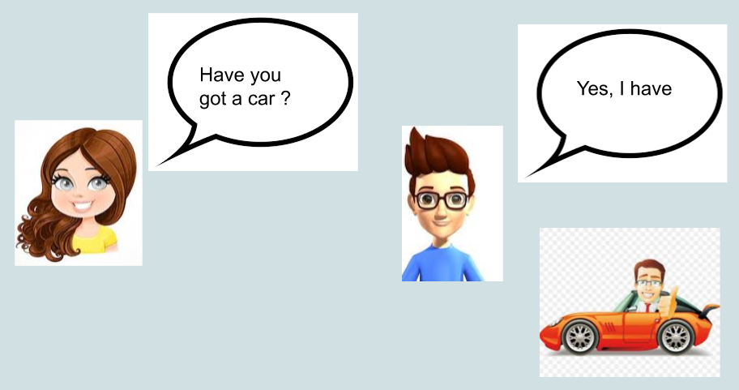
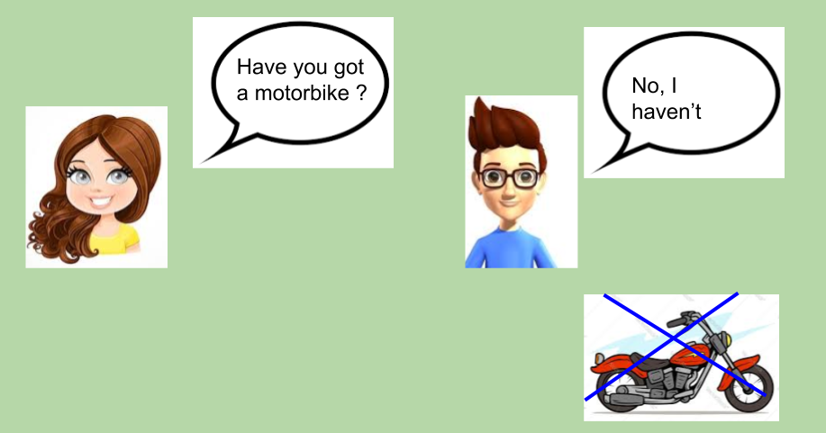

- Answer: Yes, I have / No, I haven’t ( contesta sobre vos )

- Have you got a dog ? ____________________
- Have you got brown eyes ? ___________________
- Have you got a football ? _____________________
- Have you got blonde hair ? _____________________
- Have you got a hamster ? ______________________
- Have you got a sister or brother ? ____________________

- Watch https://docs.google.com/presentation/d/1Fvhus_xB6FT3m-PYrhQY16aBd_meuDrzdffjfi_0bH8/edit?usp=sharing
Pupil’s book pages 18 and 19 / Activity book pages 14 and 15

- Now check your answers https://docs.google.com/presentation/d/1F_os2cYimZLVGFjpLeCCcKXNty354oXI_SpaA0IXgPg/edit?usp=sharing

- Look at the monster and complete using

nose / teeth / eyes / hair
