ESCUELA NUESTRA SEÑORA DEL VALLE

Queridos chicos y estimadas familias: Hoy comenzamos la unidad 5 relacionada a los trabajos:
- Jobs
- What do you want to be ?
( Recordar al entregar las tareas escribir en el asunto: nombre/ grado y fecha a la que corresponde el trabajo )
¡Felicitaciones por el esfuerzo que siguen realizando !
¡Que tengan una muy buena semana !
Saludos Miss Marian

October 19th , 20th and 21st 4th grade

Hello children ! ___________
How are you ? _________________
What’s the weather like today ? __________________

- Revision Transport: Crossword puzzle https://www.educaplay.com/learning-resources/7124645-means_of_transport.html

- Revision Transport :Memory game https://www.educaplay.com/learning-resources/7060991-means_of_transport.html

- Revision Watch https://www.loom.com/share/f785eb230f6c4be285f8efbc9478ffa6?from_recorder=1

- Watch https://docs.google.com/presentation/d/12MqfX6YZU3FrvCsLlHqdmrBrx2frt6zx5-VmGw1GJxU/edit?usp=sharing
Puìl’s book pages 40 and 41 / Activity book pages 34 and 35

- Check your answers https://docs.google.com/presentation/d/1wART7FG0DdL31dl5CefbKNEP_XaTaUj4n3FezgC4gPY/edit?usp=sharing

- Jobs: Watch https://www.loom.com/share/35b6213f9b7049eabaa2e103fecc4257?from_recorder=1

- Unit 5 Jobs
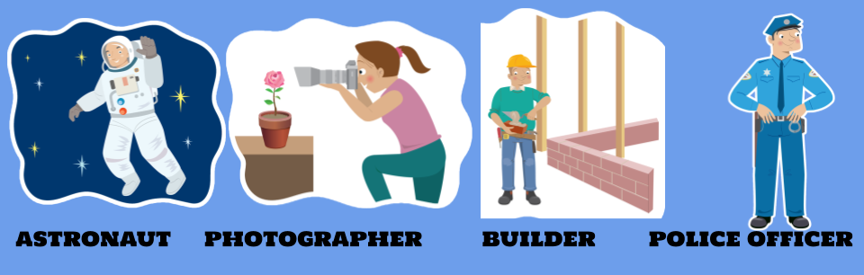

- Look and circle the correct alternative :

- It’s stormy / cloudy / rainy.
- It’s spring / summer / autumn / winter.
- Miguel likes playing computer games / football / the guitar.
- He has got a cat / dog / horse .
- He has Music / ballet lessons on Thursdays.
- On Fridays, he goes to the park by bike / goes to the park by car / walks to the park
- On Saturdays, he goes to school / a party / the cinema.
- He has Music lessons at half past three / seven o’clock / half past seven.

