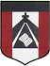
ESCUELA NUESTRA SEÑORA DEL VALLE

November 2nd, 3rd and 4th 3rd grade

- Revision Clothes : 1- Play ( jumper= sweater ) https://es.educaplay.com/recursos-educativos/7303185-memory_game_clothes.html

- Watch https://www.loom.com/share/aa3db457fd2e44c78cbe3e3ad9a1ef75?from_recorder=1
- Watch https://www.loom.com/share/b8b44144cf4b408aaa3f72cc69300059?from_recorder=1

- True or false ? ( Escribir si las oraciones son verdaderas o falsas de acuerdo a lo que Paulo está usando )

- Paulo is wearing a scarf. ____________
- He is wearing a cap. _______________
- He’s wearing a T-shirt. _____________
- He’s wearing a school uniform. _______
- He’s wearing a shirt. _______________

- Is he wearing… ? Is she wearing …?
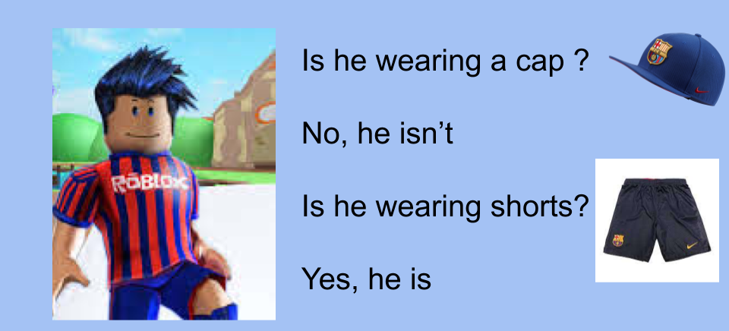

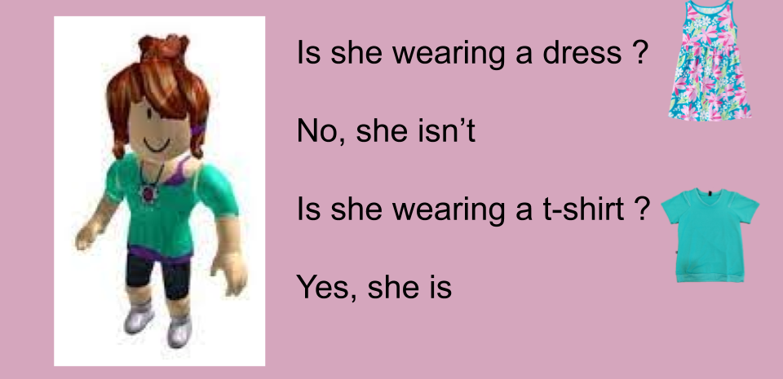

- Watch https://docs.google.com/presentation/d/1L9-_Sq4bm9iiZ7bCgsC31zG4j_NTuYSA09yObUliJyM/edit?usp=sharing
Pupil’s book pages 46 and 47 / Activity book pages 40 and 41 ( te podés ayudar con el punto H )

- Check your answers https://docs.google.com/presentation/d/1rAom5H2DMUIkZFnNt-VQp3IhIq7Kt2bVumh-eJnVfGQ/edit?usp=sharing

- Household chores
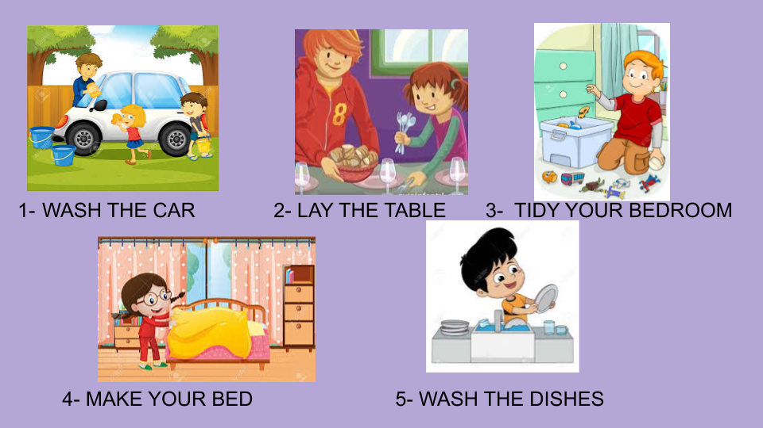

- Write “YES” or “NO” ( de acuerdo a si hacés estas tareas en tu casa o no )

- I wash the car. _________
- I lay the table. _________
- I tidy my bedroom. ________
- I make my bed. __________
- I wash the dishes. ________

Miss Marian

