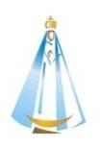
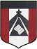
ESCUELA NUESTRA SEÑORA DEL VALLE
June 16th and 17th 3rd Grade
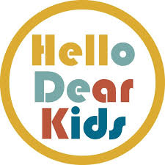
A)Revision: My face Watch https://youtu.be/2Hmq74bQP6s

B) Watch https://www.loom.com/share/20760156213c48efa8848c1c0d6f761b

C) Revision Head : Play https://learnenglishkids.britishcouncil.org/es/node/18074

D) Watch https://docs.google.com/presentation/d/1WvI2MGmC4zVd3ONsFZFqgDLZgjC-Ye1NJ8wHfiOSc1I/edit?usp=sharing
Pupil’s book page 17 / Activity book page 13

E) Now check your answers https://docs.google.com/presentation/d/1Qipjus_WJC2W4y6EneRAN5jtLd2DXu7eaV1-lswCdGo/edit?usp=sharing

F) Revision + Teeth / neck
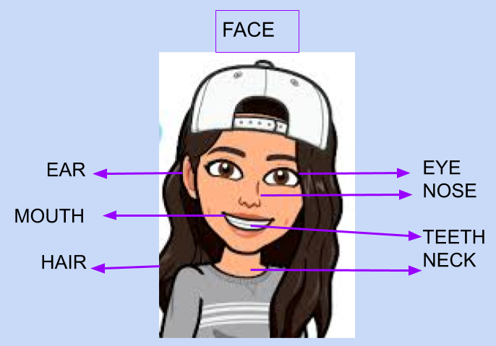

G) Draw : Draw a face with… ( dibujar una cara con lo que dice en cada cuadrito )

a beard | a moustache | glasses | blonde hair | a big nose

green eyes | teeth | a long neck | short hair

H) Has got / hasn’t got
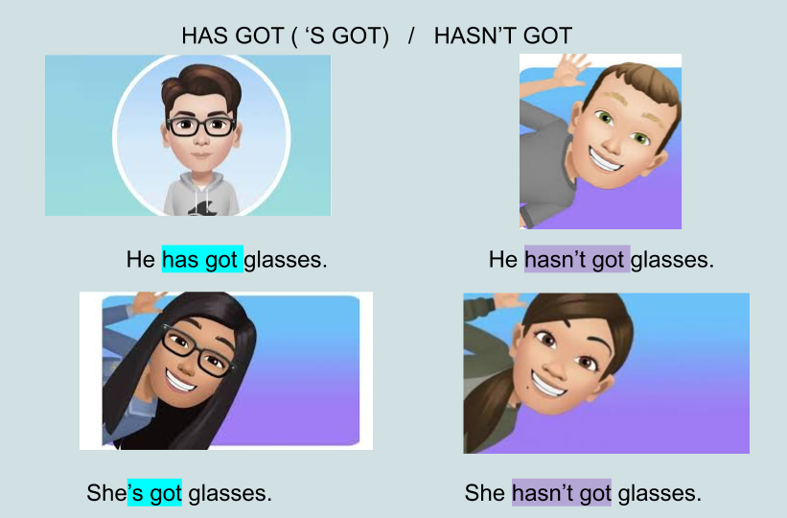

I) Circle the correct alternative
J) Have got / Haven’t got

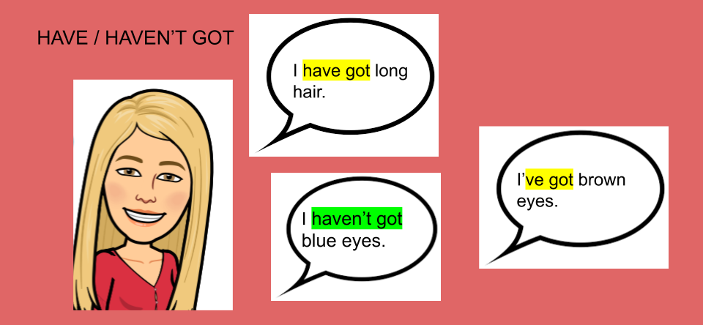
K) True or false about yourself ( sobre vos mismo )

- I have got long hair. __________________
- I have got short hair. __________________
- I’ve got blonde hair. __________________
- I’ve got brown hair. _______________
- I've got glasses. _______________
- I’ve got a moustache._______________
- I’ve got a beard. _______________

