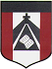
ESCUELA NUESTRA SEÑORA DEL VALLE

October 26th , 27th and 28th 5th grade
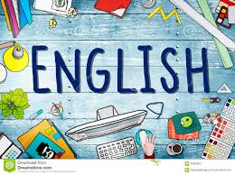

Hello dear children ! ____________________

How are you ? ________________________

- Revision How much is are https://youtu.be/2HxaqkG44PE

- Revision Clothes Play https://es.educaplay.com/recursos-educativos/7303185-memory_game_clothes.html

- Revision Clothes: Play https://es.educaplay.com/recursos-educativos/7221552-clothes_memo_test.html

- Watch https://www.loom.com/share/72a02328cad94935ba9a74f796ec1f17?from_recorder=1

- More Clothes
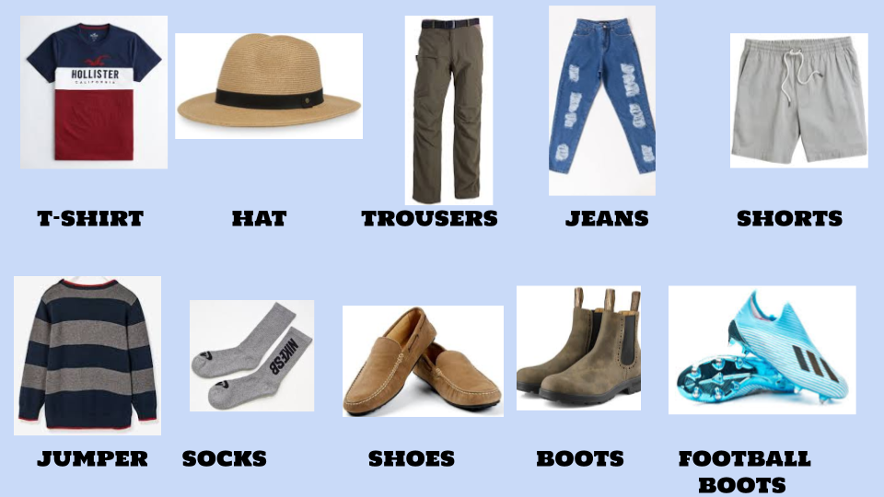

- Adjectives

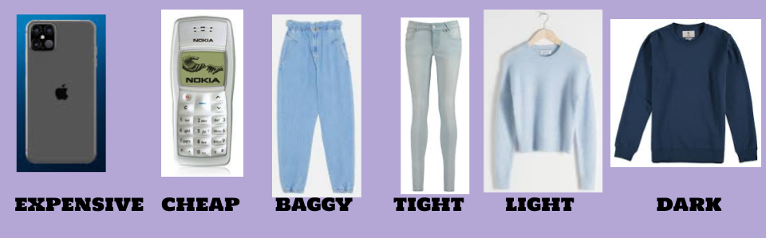

- Too

- Watch https://docs.google.com/presentation/d/1cFOlaimjj2MBdI2tRmr5K3-lzQgTD3uUs7JGOoMvWZ0/edit?usp=sharing
Pupil’s book pages 43 and 44 / Activity book pages 39 and 40

- Check your answers https://docs.google.com/presentation/d/1z-ZaaLCmwPNEM4vbGYl7sS8RGs6GkGUttkqG_IiNMT0/edit?usp=sharing

- Look and write the clothes

trainers / scarf / dress / wallet / sandals / gloves / jacket / sunglasses / umbrella / swimsuit /

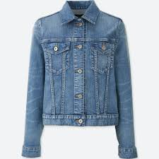 | 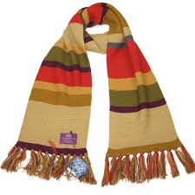 |  | 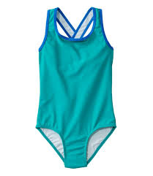 | 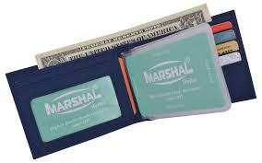
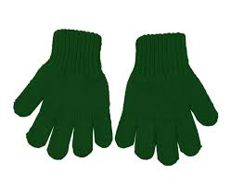 | 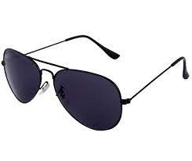 | 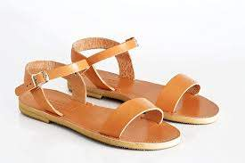 | 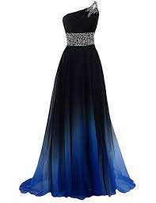 | 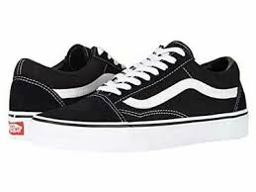

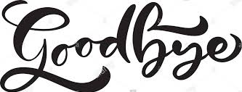Miss Marian

