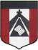
ESCUELA NUESTRA SEÑORA DEL VALLE

September 28th and 29th 5th grade

Hello dear children ! _______________
How are you today ? ________________

- Nature https://learnenglishkids.britishcouncil.org/es/node/18087

- Nature Play https://learnenglishkids.britishcouncil.org/es/node/18086

- There is Memory game https://matchthememory.com/thereis4thgradevuriloche

- Watchhttps://www.loom.com/share/2597e6659c644e26b756caf71efe6b5d

- Watchhttps://www.loom.com/share/82eeb4b0ebac4654bfc86478fd64d5c0

- Where …. from ?

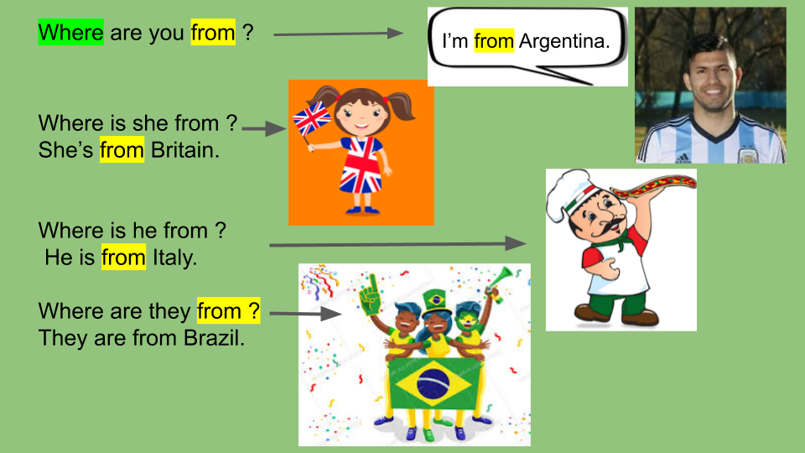

- Watch https://docs.google.com/presentation/d/1C7_Sd8-Qmp1XBTD-4IGLOnbWkzV_9O1dldi-KghYDS0/edit?usp=sharing
Pupil’s book page 37 / Activity book page 33

- Check your answers https://docs.google.com/presentation/d/19eJSMsijwNj3TmPCpFGJp9-CQEaL6HIxLutgd4_OwbA/edit?usp=sharing

- Complete: ( Elige tu país favorito , averigua su nombre en Inglés, dibuja su bandera y escribe en “Places of interest”, de acuerdo a si hay : pyramids / caves / forests / lakes / islands / statues / desert / cities / volcanoes / waterfalls / mountains / )

My favourite country

Country:

Flag:

Places of interest:

- Answer

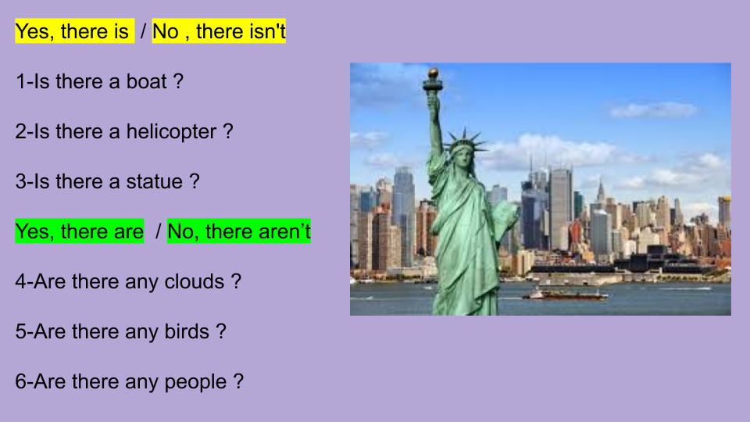

- ______________________
- ______________________
- ______________________
- ______________________
- ______________________
- ______________________

Miss Marian

