“María, Madre del pueblo. Esperanza nuestra”
-400 años del hallazgo de la imagen de Ntra. Sra. del Valle-

HELLO DEAR STUDENTS! HOW ARE YOU ALL? I HOPE YOU ARE OK. HERE ARE THE ACTIVITIES FOR THIS WEEK. EMAIL ME THE ANSWERS, PLEASE: CMURGA@INSTITUTONSVALLECBA.EDU.AR . DO THE ACTIVITIES IN YOUR FOLDERS AND SEND ME THE PICTURES SO I KEEP A RECORD OF YOUR WORK. (PLEASE, IN THE SUBJECT OF YOUR EMAILS INCLUDE: NAME AND SURNAME AND THE YEAR YOU ARE IN, EXAMPLE: SOLEDAD TORRES, 2DO “B”). SOMETIMES YOU WILL CHECK THE HOMEWORK, OTHER TIMES, I WILL DO IT AND OTHER TIMES WE WILL CHECK THEM WHEN THE QUARANTINE PERIOD IS OVER.
AS YOU KNOW, WE WILL START USING THE PLATFORM “GOOGLE CLASSROOM”. MOST OF YOU ARE FAMILIAR WITH THIS. HERE IS THE CODE FOR THE ACTIVITIES: 7hbws2f

OBJECTIVES FOR THIS CLASS:
- TO REVIEW THE SIMPLE PRESENT AND PAST TENSE IN ALL FORMS (AFFIRMATIVE, NEGATIVE AND INTERROGATIVE FORMS)
- TO REVIEW THE ADVERBS OF FREQUENCY
- TO LEARN GERUNDS

ACTIVITIES:
- RECAPITULATION: WHAT DID YOU LEARN LAST CLASS?
- REVISION OF ADVERBS OF FREQUENCY. IF POSSIBLE, PRINT THE COPY BELOW, CUT THE STRIPES, SITCK THEM IN YOUR FOLDERS AND ANSWER THE QUESITONS. 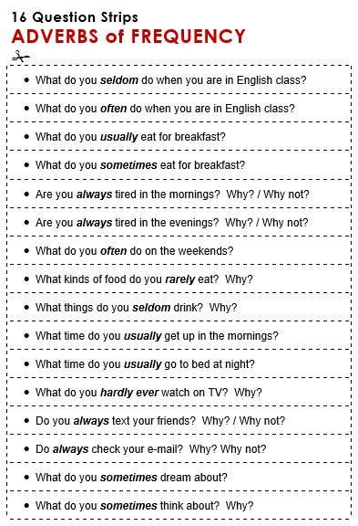
- GERUNDS: WE ARE GOING TO LEARN ABOUT GERUNDS.
LOOK AT THE SENTENCES:
MANY PEOPLE ENJOY WATCHING FILMS
HE DOESNT LIKE BEING FAMOUS
WHAT IS HE KEEN ON DOING IN HIS FREE TIME?
WHAT DO THEY HAVE IN COMMON?
ANSWER: ( A VERB + VERB ENDING IN “ING”)
THESE “-ING” FORMS ARE CALLED “GERUNDS”.
- STUDENT’S BOOK “PHASES 3” PAGE 11. DO ACTIVITIES 10, 11, 12 AND 13.
- STUDENT’S BOOK “PHASES 3” PAGE 118. GERUNDS ACTIVITY. DO EXERCISES 3 AND 4.
- “PHASES 3” WORKBOOK PAGES 9: ALL THE PAGE
- LET’S DO AN EXERCISE TO REHEARSE “GERUNDS”!
COMPLETE THE GAPS WITH A GERUND (EXAMPLE: LEARNING) OR AN INFINITIVE (EXAMPLE: TO LEARN)
THEN, CLICK ON THE LINK, LISTEN AND CHECK!
(THERE IS ANOTHER LINK FOR YOU TO DOWNLOAD THE ACTIVITY IN CASE YOU CAN NOT READ IT FROM HERE)

LINKS:
https://drive.google.com/file/d/0Bw0KTcTWS-mud3Q2YWlDT0xEd0U/view?usp=sharing&fbclid=IwAR2JNMchtgslpYo3IQ1hm6KbTzpSGJtEa_wwvssxkbHOftFrCrymd-fziJc
https://soundcloud.com/user-867861522/gerunds-or-infinitives-songs?fbclid=IwAR0HDBNYZI98Ci7z3afgtLSL0ay5R1LkQthWfpT9uBoqGPy3EWo_BlUwGx4

CRITERIOS DE EVALUACION:
- PARTICIPACION VIRTUAL
- COMPRENSION LECTORA
- CUMPLIMIENTO DE CONSIGNAS
- CUMPLIMIENTO DE TAREAS EN TIEMPO Y FORMA
- ESCRITURA CON CONTENIDO CLARO Y PERTINENCIA

THAT’S ALL FOR THIS WEEK. THANKS AGAIN FOR YOUR RESPONSIBILITY AND COMMITMENT.
MISS CONSU

