ESCUELA NUESTRA SEÑORA DEL VALLE

October 26th , 27th and 28th 4th grade

- Revision Jobs: Play https://es.educaplay.com/recursos-educativos/6599581-find_the_jobs.html

- Watch https://www.loom.com/share/2bc78812abf24efab893e652974a0073?from_recorder=1

- a / an
Examples: a builder an astronaut

- He is a … She is a …
She is a photographer. He is a tennis player.

- Write sentences using He is a …… She is a ……….. ( escribir oraciones contando la profesión de cada uno. Te podés ayudar con el Activity b. Page 71. Recordar que si la palabra empieza con vocal se dice an en vez de “a” )

- 2. 3. 4.
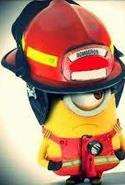
5. 6. 7. 8.

- __________________________

- __________________________

- __________________________

- __________________________

- __________________________

- __________________________

- __________________________

- __________________________

- What do you want to be ?
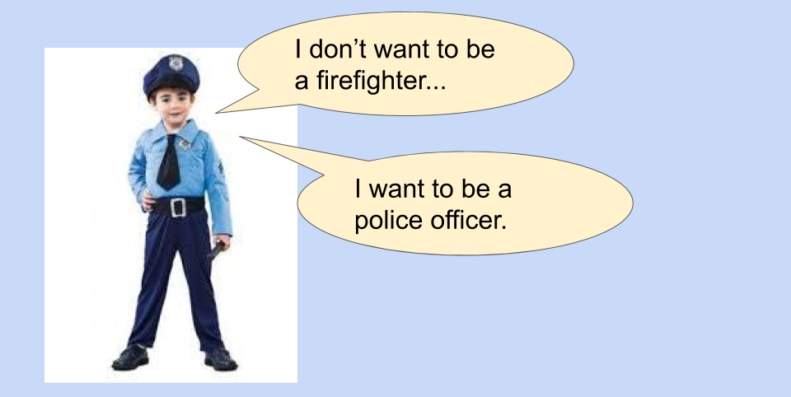

- Watch https://docs.google.com/presentation/d/1zfFX3oVkCbyiON4JK4bZhI-5co41lst5zjHzKnL9As4/edit?usp=sharing
Pupil’s book pages 42 and 43 / Activity book pages 36 and 37

- Check your answers https://docs.google.com/presentation/d/17-Wkb_oqlDd3Y7E4KjjaYr2TEPNUuoFZurE9S-_M9RQ/edit?usp=sharing

Miss Marian

