“María, Madre del pueblo. Esperanza nuestra”
-400 años del hallazgo de la imagen de Ntra. Sra. del Valle-

DEAR STUDENTS,
HERE ARE THE ANSWERS FOR THE ACTIVITIES I SENT LAST CLASS. SOME ACTIVITIES WILL BE CHECKED BY ME, OTHERS BY YOU AND OTHERS WHEN WE GET TOGETHER AGAIN.
PLEASE, IT’S VERY IMPORTANT THAT YOU DO THE SELF CORRECTION TO COMPLETE THE PROCESS OF LEARNING.
ACTIVITIES:
- WE USE THE SIMPLE PRESENT TENSE TO TALK ABOUT ACTIONS THAT HAPPEN EVERYDAY, AND THE PRESENT CONTINUOUS TENSE TO TALK ABOUT ACTIONS HAPPENING AT THE MOMENT OF SPEAKING.
QR CODE ACTIVITIES:
- WHAT DO YOU THINK ABOUT THE NEW SHOPPING CENTRE?
- SHE DOESNT UNDERSTAND WHAT I’M SAYING
- WHAT’S HE DOING? HE IS TASTING THE MEAT TO SEE THAT IT’S OK
- JIMMY DOESNT SEEM VERY HAPPY AT THE MOMENT
- GINA IS THINKING ABOUT HER OWN BUSINESS
- WHICH COLOUR DO YOU PREFER, GREEN OR BLACK?
- LOOK! ARE YOU SEEING THE WOMAN OVER THERE?
- THE CAR BELONGS TO THE MAN NEXT DOOR
- SHE IS SEEING THE DENTIST NEXT WEEK
- I AM HAVING TEA WITH SARAH AT 8PM

- I LEARNED VOCABULARY ABOUT HOBBIES AND GAMES SUCH AS: ROLL A DICE, GUESS, LAND, LOSE, CHEAT-MISS A TURN, CHEAT, MOVE A COUNTER.
- PAGE 8. EX1:
- THE SIMPLE PRESENT
- DO/DOES
- WAS/WERE
- DID
EX.2: 1-HAS; 2-TAKE, DON’T LIKE; 3-WINS; 4-DID, BEAT; 5-DOES, TAKE
EX.3: 1- WAS BORN; 2-WON; 3-PLAYS; 4-MAKES; 5-DIDNT GO; 6-IS

6. PAGE 9.
EX. 4: 1-PLAY; 2-DO, KNOW; 3-WAS BORN; 4: LOVED; 5-STUDIED; 6-BEGAN; 7-INVENTED; 8-DIDNT CALL; 9-FOUND; 10-BECAME
EX.5:
- DO YOU OFTEN PLAY BOARD GAMES WITH YOUR FRIENDS AT SCHOOL?
- WHO DO YOU USUALLY PLAY BOARD GAMES WITH?
- WHAT BOARD GAMES DO YOU USUALLY PLAY AT HOME?
- DID YOU PLAY ANY BOARD GAMES AT HOME LAST WEEKEND?
- DID YOU LOSE OR WIN?
- HOW LONG DID YOU PLAY?
- DID YOU HAVE A GOOD TIME?

WORKBOOK PAGES 6 AND 7:
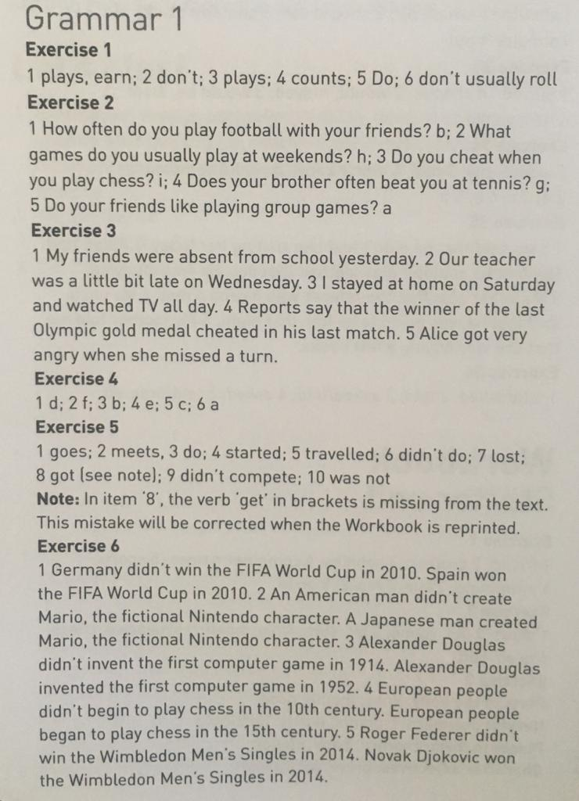
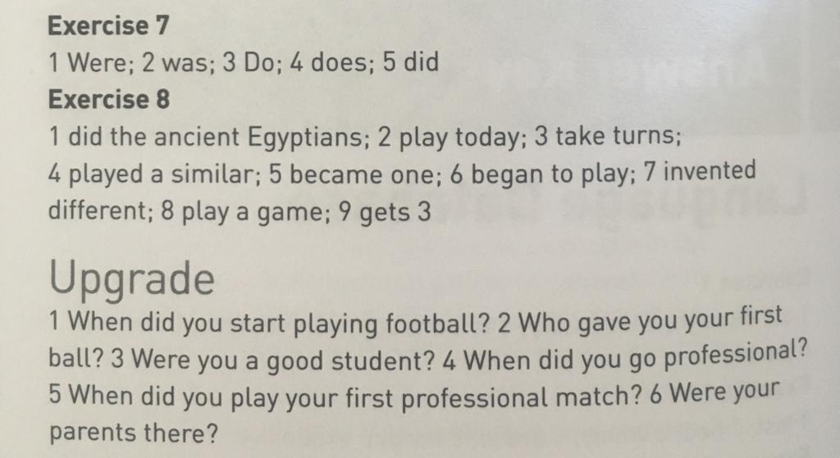
THANK YOU ALL!

