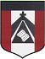
ESCUELA NUESTRA SEÑORA DEL VALLE

ENGLISH CLASSES ON LINE Due date (fecha de entrega): June 26th

PROFESSIONS: Write the name.
………… …………….. …………………

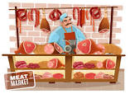

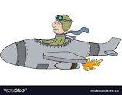
……………

……………………….
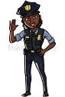
…………………… ……………………
……………………..

……………………
… ……………………

……………………
……………………
……………………

COMPLETE WITH ONE OF THESE VERBS
(Use a dictionary or wordreference.com )

Takes care of delivers works sells makes helps
performs helps teaches
works entertains flies puts out makes

A teacher ……… at schools.
A postman …………. letters.
A vet ………… injured animals.
A cook ………… at restaurants.
A secretary ………….. in an office.
A doctor …………. ill people.
An artist ……….. works of art.
A butcher ………….. meat.
A baker …………… bread.
A clown ……………. people.
A pilot ………….. planes or helicopters.
A fireman ……………. Fires.
A dancer ……………. in theaters.
A police officer …………… people.

SEE YOU NEXT WEEK!!

