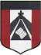
ESCUELA NUESTRA SEÑORA DEL VALLE
Queridos chicos y estimados padres:
Comenzamos otra semana con nueva unidad.
Los objetivos son:
- Aprender vocabulario relacionado a la descripción física de una persona
- Reconocer “have got/ has got”
- Identificar palabras en un párrafo breve
¡Gracias por el acompañamiento! Un afectuoso saludo Miss Marian

June 8th,9th and 10th 3rd grade
How are you today ? __________
- Watch the presentation https://www.loom.com/share/975bf07f93e347ee8529acf2570ab2cd

- HE / SHE
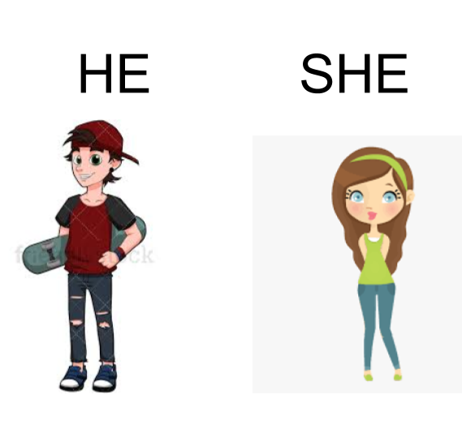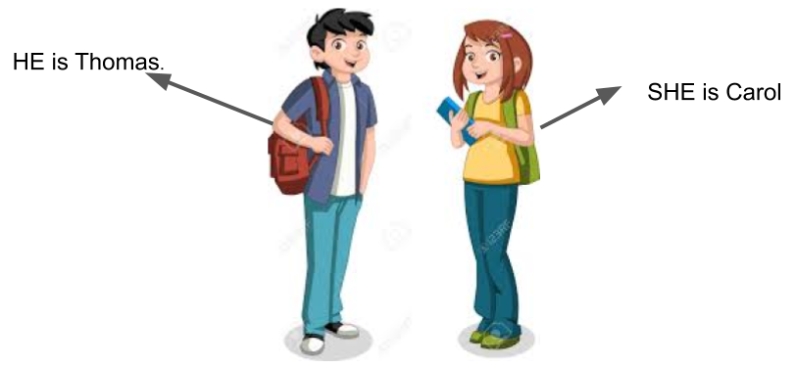

- Complete using He or She

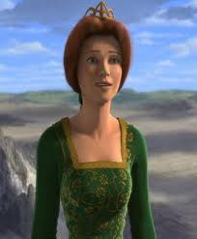 | 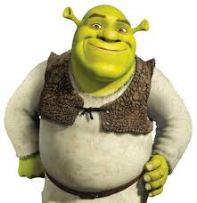 | 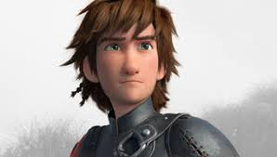 | 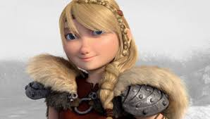 | 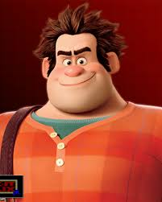

- ________ is Fiona.
- ________ is Shrek.
- ________ is Hipo.
- ________ is Astrid.
- ________ is Ralph.

- FACE : Watch https://youtu.be/6pLFxeumlpE

- Revision

- LONG / SHORT / BIG / SMALL
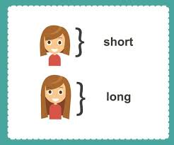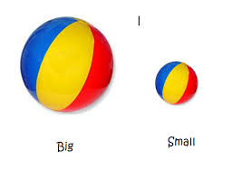

- Vocabulary
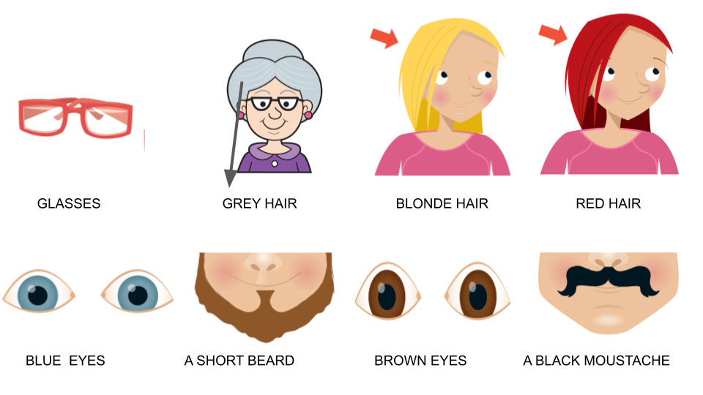
- Has got
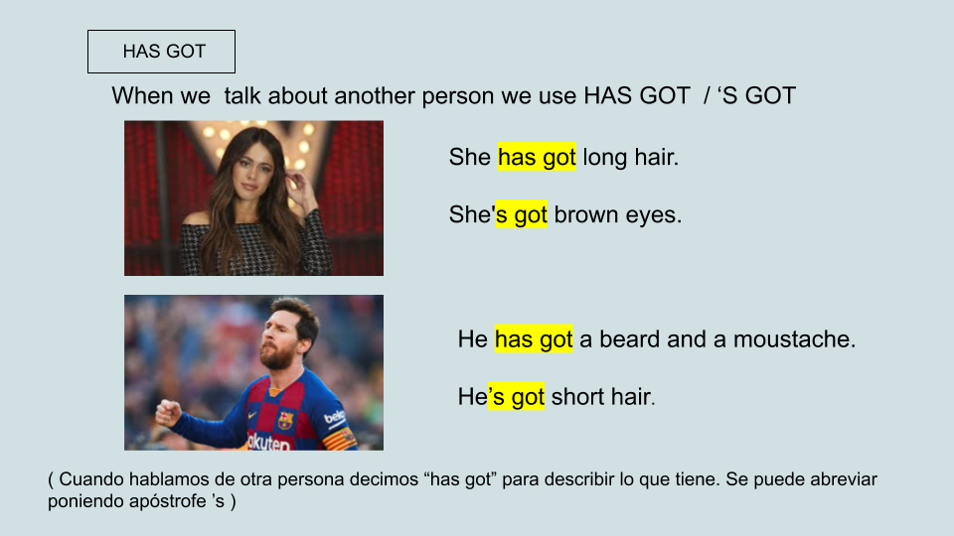

- Watch the presentation https://docs.google.com/presentation/d/1HbhFFS0xuvUcBp52gH1tDRwoCjt82YOUr0xOP8RVmXw/edit?usp=sharing
Pupil's book page 16 / Activity book page 12

- Look and write the number ( mira los dibujos, lee las oraciones y escribe el número de la persona que corresponda. Fijate si dice He o She )

1 | 2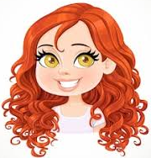 | 3
4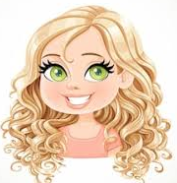 | 5 | 6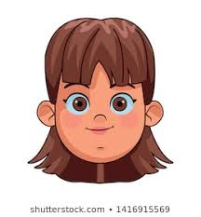

a- She has got brown eyes. _______
b- She's got glasses. _______
c- He has got a big moustache. _______
d- He's got a beard. _______
e- She´s got grey hair. _______
f- She’s got red hair. _______
g- She’s got blonde hair. _____

- Now check your answers https://docs.google.com/presentation/d/1knMRsUWfNgWZHdE5FVbsX_BPdKKykBczt1uzWMSbPp0/edit?usp=sharing

