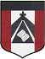
ESCUELA NUESTRA SEÑORA DEL VALLE
Queridos chicos y familias: Recuerden que el próximo año se continuarán con las tres unidades restantes del libro. Por lo que es muy importante conservarlo para seguir utilizándolo.
Gracias por la colaboración y el esfuerzo realizado.
Los saluda con cariño Miss Marian

November 16th, 17th and 18th 4th grade

Hello dear children ! ______________

How are you ? ___________________

What’s the weather like today ?
______________________________

- Jobs : Play https://learnenglishkids.britishcouncil.org/es/node/17877

- Jobs : Watch https://youtu.be/tQ03ENVgRfg

- Watchhttps://www.loom.com/share/c63b2f8b558247c9a607491de4c59da2

- What does he want to be ?
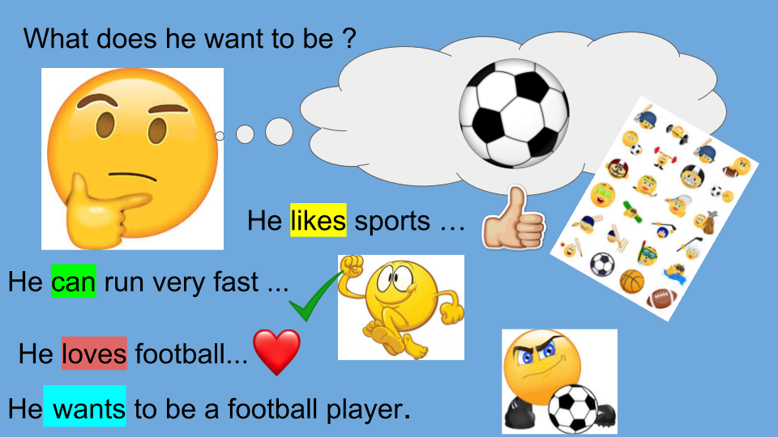

- Watch https://docs.google.com/presentation/d/1rDtsWmN1K-9N1USf9SPTTi99rZ_5v2WM6q6JZP8Kq3U/edit?usp=sharing
Pupìl’s book pages 48 and 49 / Activity book pages 42 and 43

- Check your answers https://docs.google.com/presentation/d/1iarKlY8CDJsxvZ7QfLRQOIJWHzV_t6VH4lXIih3IRIQ/edit?usp=sharing

- Complete :

My favourite …
singer is ___________________
film star is _________________
football player is ____________
tennis player is ______________
basketball player is __________
teacher is __________________

Miss Marian

