ESCUELA NUESTRA SEÑORA DEL VALLE
4th grade
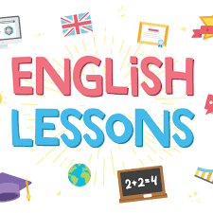
October 13th and 14th

Hello dear children ! ___________
How are you ? ___________
What’s the weather like ? __________

- Revision Transport : Play https://www.educaplay.com/learning-resources/7152060-memory_game.html

- Watch https://www.loom.com/share/f469842ce4d54b8d99660ba956e49b2b

- Go ...
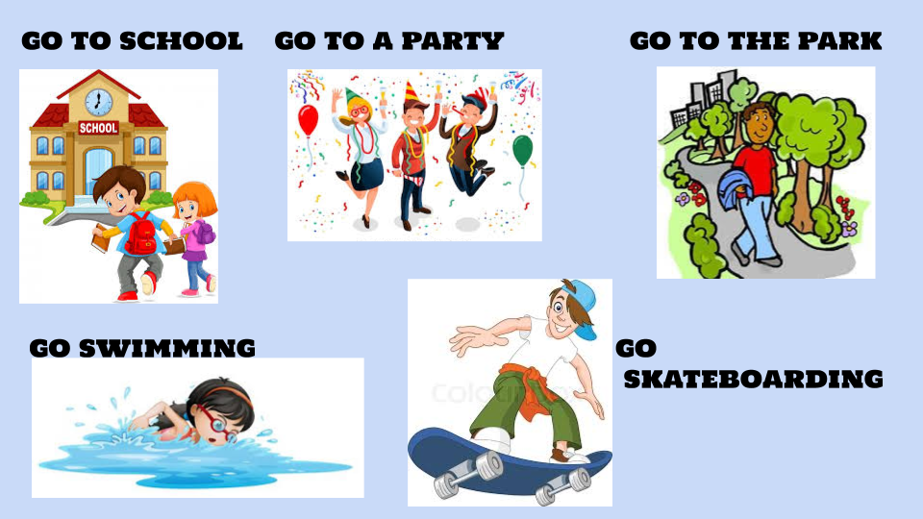

- How do you go to school ?
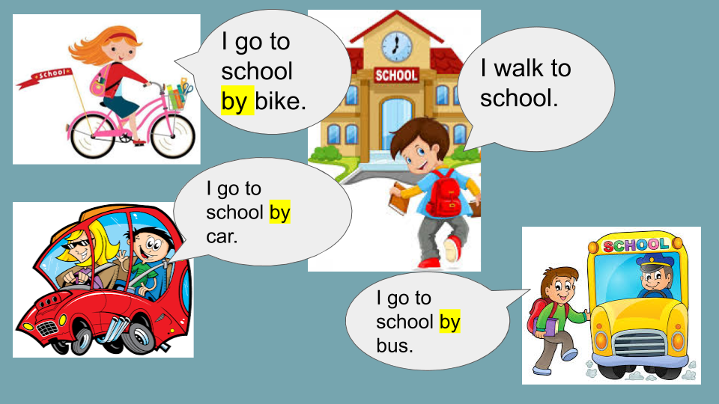

- How does he / she go to …?

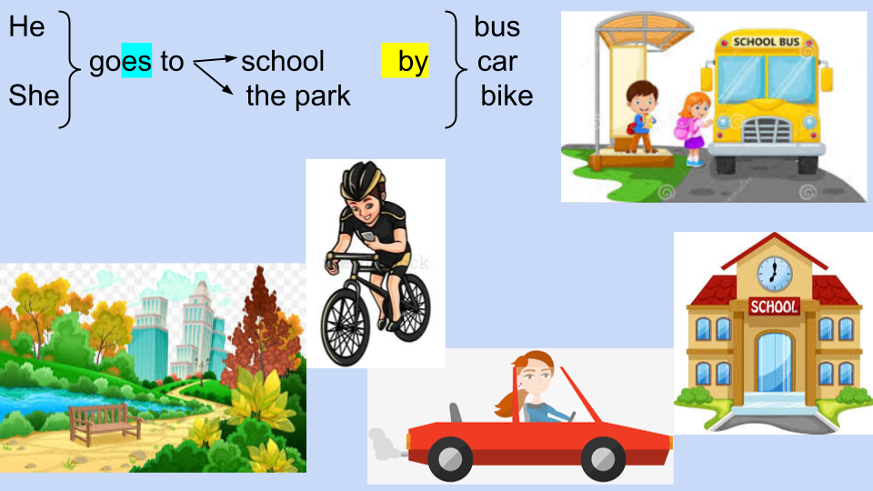

- Watch https://docs.google.com/presentation/d/1r1AoxbUGpqzjdPZMhSYAK9yanSjIQ1WH4x8V3bO5ekM/edit?usp=sharing
Pupil’s book pages 38 and 39 / Activity book pages 32 and 33

- Check your answers https://docs.google.com/presentation/d/1dW_m57OfiSM4FhtUeEkgbSC0zByNyE550Vf-XkvP6O4/edit?usp=sharing

- Fill in the blanks using :

spaghetti / twenty / bike / He / karate / half / ears / goes / China /

- _______________ is Po.
- He is _____________ years old.
- He has got small black ___________.
- He lives in _______________.
- He likes _________________.
- He does ________________ on Mondays and Fridays.
- He does gymnastics at ___________ past two.
- In the afternoon he ____________ to the park.
- He goes to the park by _____________.

Miss Marian

