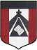
ESCUELA NUESTRA SEÑORA DEL VALLE

Queridos chicos y estimadas familias: ¡ Buena semana para todos !
Hoy terminamos la unidad 4 y comenzamos la unidad 5, donde trabajaremos diálogos breves para comprar ropa:
- Clothes / Adjectives
- Numbers 1 to 1000
- How much is / are ?
¡Felicitaciones por el esfuerzo que continúan realizando !
Los saludo con cariño Miss Marian
( recordar al enviar los trabajos escribir en el asunto: Nombre / grado / fecha del trabajo )

5th grade
October 13th and 14th

Hello children ! ____________________

How are you today ? ________________

- Revision Countries: Play https://wordwall.net/resource/2017266/countries

- Revision There is / are: Play https://wordwall.net/resource/617269/there-there-there-isnt-there-arent

- Revision: Look at the picture and complete using :
There is / There isn’t / There are / There aren’t

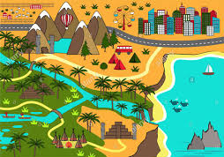

- ____________ _______ some mountains.
- ____________ _______ a bus.
- ____________ _______ a volcano.
- ____________ _______ any lions.
- ____________ _______ four pyramids.

- Fill in the blanks using:

sushi / beautiful / Her / green / gets / young / and / singing / The USA / thirty four / blonde / singer / clever

- _________ name is Lady Gaga.
- She is a famous _____________.
- She is _____________ years old. She is _____________.
- She is from _______________.
- She has got straight ___________ hair and ___________ eyes.
- She is tall _____________ slim.
- She is _________________.
- She is ______________ and kind.
- She is very good at _______________.
- She likes _______________.
- She ______________ up at half past six every day.

- Numbers 1 to 100: Watch https://drive.google.com/file/d/1L-UsKqyst1JM5TagHY7FRE7fnAn3FKVf/view?usp=sharing

- Numbers 1 to 100 : Read
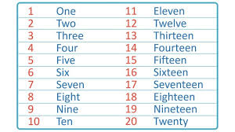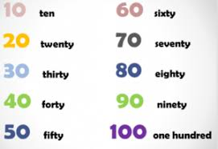
Examples : 23 Twenty-three 96 Ninety-six
58 Fifty- eight 41 Forty-one

- Numbers 10 to 100:Play https://es.educaplay.com/recursos-educativos/6485416-counting_by_tens.html

- This/ That / These / Those Watch https://youtu.be/TkpSsdQCaKY

- Watch https://www.loom.com/share/43e8c5eef24e4426abefb2f5ccbb7904

- Clothes and accessories
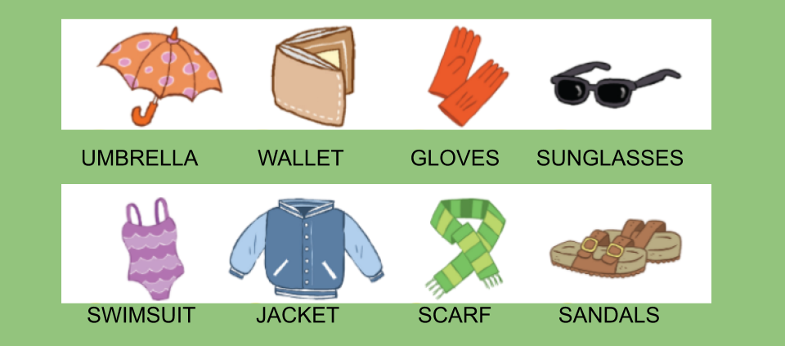
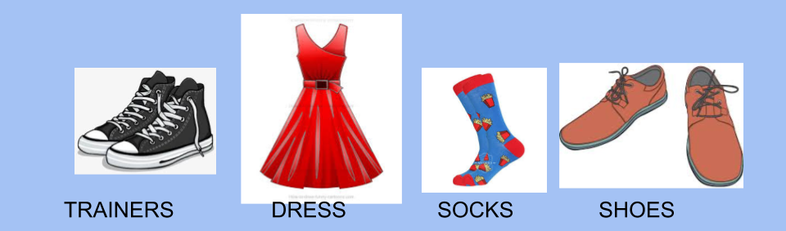

- Watchhttps://docs.google.com/presentation/d/1OAthWMvjyFU9_KmOt4OC9s48DV7vb9NpqOTdatdlbAY/edit?usp=sharing
Pupil’s book page 40 / activity book page 36

- Check your answers https://docs.google.com/presentation/d/17jE7jTfv610phA-54Kst--0n7OtELC5ytaqDRS6bkmM/edit?usp=sharing

Miss Marian

